Exercise 1: Logging Error Messages and Warning Levels

**Step 1:- Added SLF4J and Logback dependencies to `pom.xml` file:**

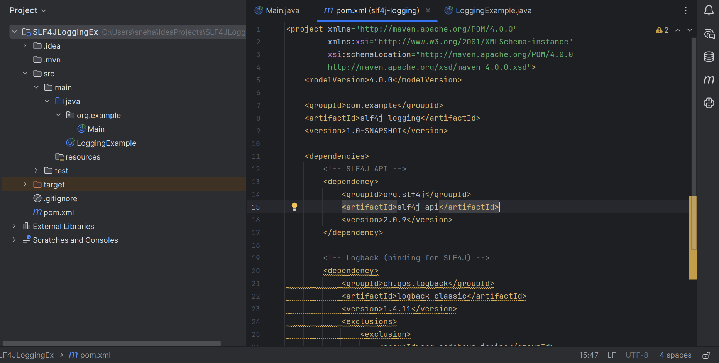

**Step 2:- . Created a Java class that uses SLF4J for logging:**

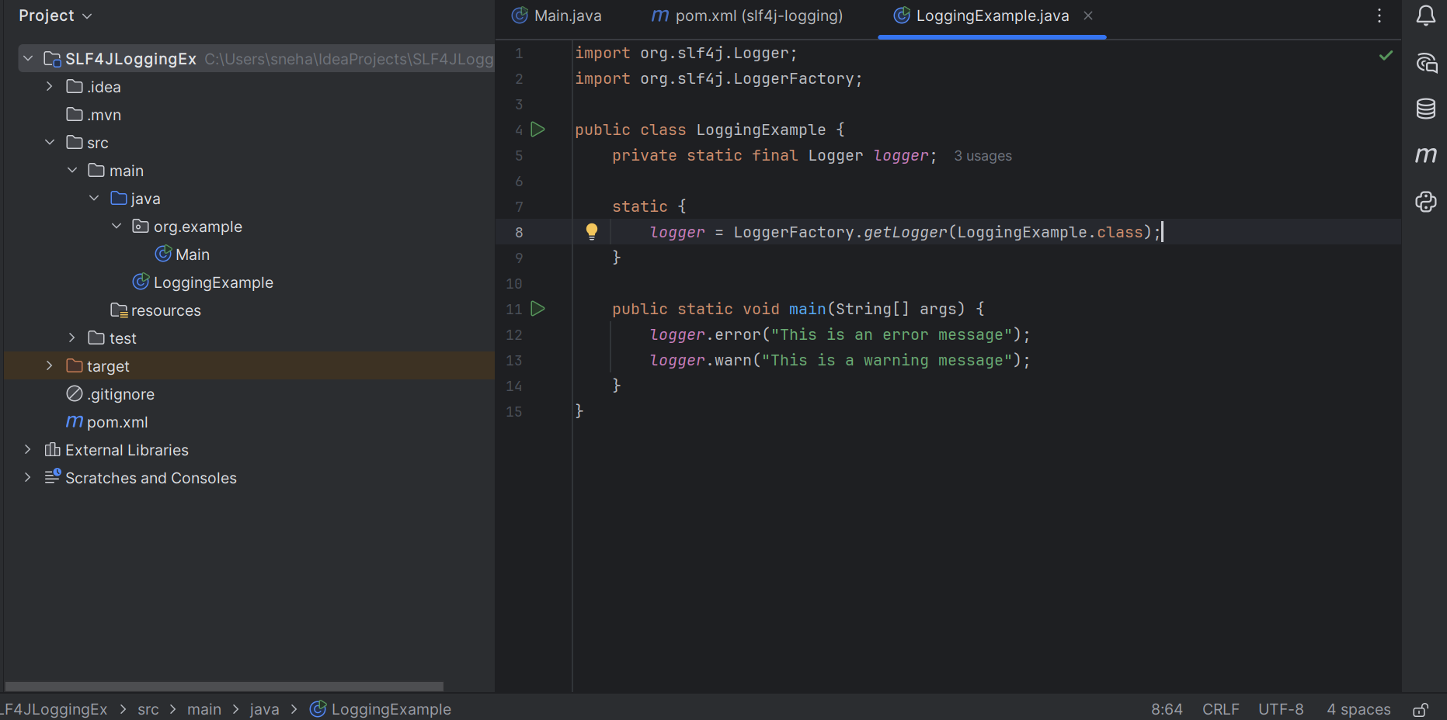

**OUTPUT:**

